**Quickstart: Create a Java app on Azure App Service**

Bottom of Form

This lab shows how to use the [Azure CLI](https://docs.microsoft.com/en-us/cli/azure/get-started-with-azure-cli) with the [Azure Web App Plugin for Maven](https://github.com/Microsoft/azure-maven-plugins/tree/develop/azure-webapp-maven-plugin) to deploy a .jar file, or .war file

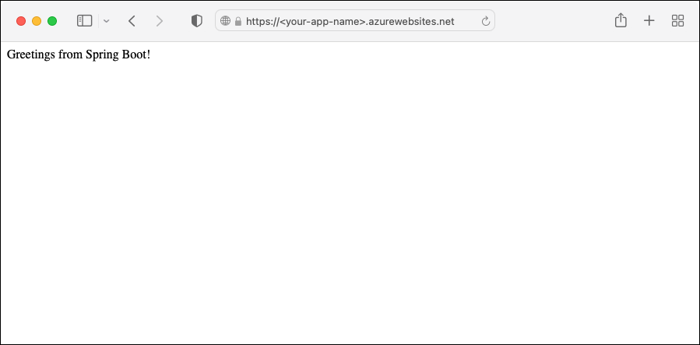

**Task 1 : Create a Java app**

1. Click on Start button and navigate to command prompt

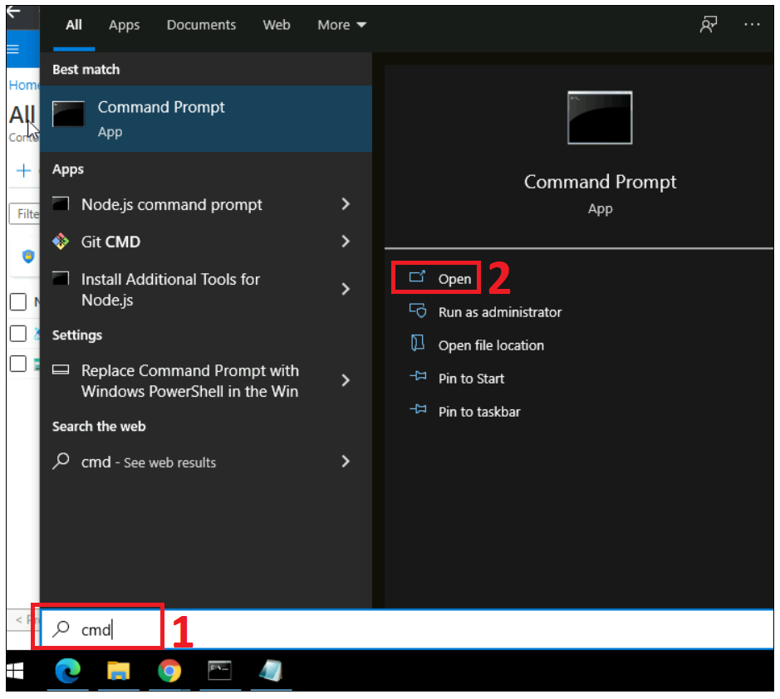

1. Clone the [Spring Boot Getting Started](https://github.com/spring-guides/gs-spring-boot) sample project.

Azure CLICopy

**git clone https://github.com/spring-guides/gs-spring-boot**

Change directory to the completed project.

Azure CLICopy

Try It

cd gs-spring-boot/complete

**Configure the Maven plugin**

**Tip**

The Maven plugin supports **Java 17** and **Tomcat 10.0**. For more information about latest support, see [**Java 17 and Tomcat 10.0 are available on Azure App Service**](https://devblogs.microsoft.com/java/java-17-and-tomcat-10-0-available-on-azure-app-service/).

The deployment process to Azure App Service will use your Azure credentials from the Azure CLI automatically. If the Azure CLI is not installed locally, then the Maven plugin will authenticate with Oauth or device login. For more information, see [authentication with Maven plugins](https://github.com/microsoft/azure-maven-plugins/wiki/Authentication).

Run the Maven command below to configure the deployment. This command will help you to set up the App Service operating system, Java version, and Tomcat version.

Azure CLICopy

Try It

mvn com.microsoft.azure:azure-webapp-maven-plugin:2.5.0:config

* [Java SE](https://docs.microsoft.com/en-us/azure/app-service/quickstart-java?tabs=javase&pivots=platform-linux#tabpanel_4_javase)
* [Tomcat](https://docs.microsoft.com/en-us/azure/app-service/quickstart-java?tabs=javase&pivots=platform-linux#tabpanel_4_tomcat)
* [JBoss EAP](https://docs.microsoft.com/en-us/azure/app-service/quickstart-java?tabs=javase&pivots=platform-linux#tabpanel_4_jbosseap)

1. When prompted with **Subscription** option, select the proper Subscription by entering the number printed at the line start.
2. When prompted with **Web App** option, select the default option, <create>, by pressing enter.
3. When prompted with **OS** option, select **Linux** by pressing enter.
4. When prompted with **javaVersion** option, select **Java 11** by entering 2.
5. When prompted with **Pricing Tier** option, select **P1v2** by entering 9.
6. Finally, press enter on the last prompt to confirm your selections.

Copy

Please confirm webapp properties

Subscription Id : ********-****-****-****-************

AppName : spring-boot-1599007116351

ResourceGroup : spring-boot-1599007116351-rg

Region : centralus

PricingTier : P1v2

OS : Linux

Web server stack : Java SE

Deploy to slot : false

Confirm (Y/N)? : Y

[INFO] Saving configuration to pom.

[INFO] ------------------------------------------------------------------------

[INFO] BUILD SUCCESS

[INFO] ------------------------------------------------------------------------

[INFO] Total time: 20.925 s

[INFO] Finished at: 2020-09-01T17:38:51-07:00

[INFO] ------------------------------------------------------------------------

You can modify the configurations for App Service directly in your pom.xml. Some common configurations are listed below:

| **Property** | **Required** | **Description** | **Version** |
| --- | --- | --- | --- |
| <schemaVersion> | false | Specify the version of the configuration schema. Supported values are: v1, v2. | 1.5.2 |
| <subscriptionId> | false | Specify the subscription ID. | 0.1.0+ |
| <resourceGroup> | true | Azure Resource Group for your Web App. | 0.1.0+ |
| <appName> | true | The name of your Web App. | 0.1.0+ |
| <region> | false | Specifies the region where your Web App will be hosted; the default value is **centralus**. All valid regions at [Supported Regions](https://azure.microsoft.com/global-infrastructure/services/?products=app-service) section. | 0.1.0+ |
| <pricingTier> | false | The pricing tier for your Web App. The default value is **P1v2** for production workload, while **B2** is the recommended minimum for Java dev/test. For more information, see [App Service Pricing](https://azure.microsoft.com/pricing/details/app-service/linux/) | 0.1.0+ |
| <runtime> | false | The runtime environment configuration. For more information, see [Configuration Details](https://github.com/microsoft/azure-maven-plugins/wiki/Azure-Web-App:-Configuration-Details). | 0.1.0+ |
| <deployment> | false | The deployment configuration. For more information, see [Configuration Details](https://github.com/microsoft/azure-maven-plugins/wiki/Azure-Web-App:-Configuration-Details). | 0.1.0+ |

Be careful about the values of <appName> and <resourceGroup> (helloworld-1590394316693 and helloworld-1590394316693-rg accordingly in the demo), they'll be used later.

[**I ran into an issue**](https://www.research.net/r/javae2e?tutorial=quickstart-java&step=config)

**Deploy the app**

With all the configuration ready in your pom file, you can deploy your Java app to Azure with one single command.

* [Java SE](https://docs.microsoft.com/en-us/azure/app-service/quickstart-java?tabs=javase&pivots=platform-linux#tabpanel_5_javase)
* [Tomcat](https://docs.microsoft.com/en-us/azure/app-service/quickstart-java?tabs=javase&pivots=platform-linux#tabpanel_5_tomcat)
* [JBoss EAP](https://docs.microsoft.com/en-us/azure/app-service/quickstart-java?tabs=javase&pivots=platform-linux#tabpanel_5_jbosseap)

Azure CLICopy

Try It

mvn package azure-webapp:deploy

Once deployment is completed, your application will be ready at http://<appName>.azurewebsites.net/ (http://helloworld-1590394316693.azurewebsites.net in the demo). Open the url with your local web browser, you should see

* [Java SE](https://docs.microsoft.com/en-us/azure/app-service/quickstart-java?tabs=javase&pivots=platform-linux#tabpanel_6_javase)
* [Tomcat](https://docs.microsoft.com/en-us/azure/app-service/quickstart-java?tabs=javase&pivots=platform-linux#tabpanel_6_tomcat)
* [JBoss EAP](https://docs.microsoft.com/en-us/azure/app-service/quickstart-java?tabs=javase&pivots=platform-linux#tabpanel_6_jbosseap)



**Congratulations!** You've deployed your first Java app to App Service.

[**I ran into an issue**](https://www.research.net/r/javae2e?tutorial=app-service-linux-quickstart&step=deploy)